**MARKET SEGMENTATION ANALYSIS OF**

**ELECTRIC VEHICLE MARKET IN INDIA**

**- Ramavath Bhaskar**

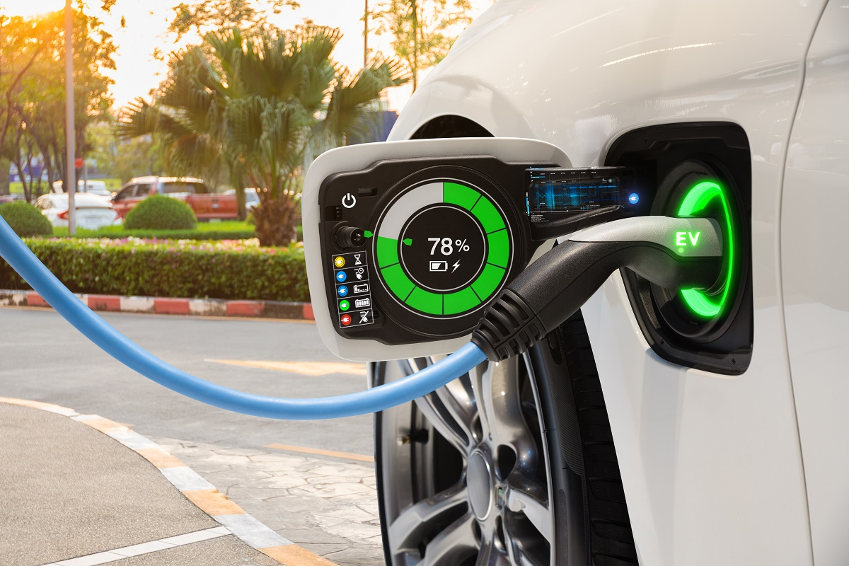

**OVERVIEW :**

In 2024, the global trend towards seeking alternative energy sources for vehicles, particularly electric vehicles (EVs), continues to gain momentum. Despite more than 90% of vehicles worldwide still relying on oil, there is a noticeable shift towards EVs due to concerns about air pollution and the need for sustainable development. In India, where the market share of EVs is currently only around 0.1%, there is growing recognition of the urgent need to transition to cleaner transportation options.

The Indian transportation sector is expanding rapidly, exacerbating issues related to greenhouse gas emissions and reliance on imported oil. With India being the third-largest emitter of CO2 globally, there is a pressing need to focus on EV technology as a pathway to zero-emission transportation.

Several factors make EVs, hybrid electric vehicles (HEVs), and plug-in hybrid electric vehicles (PHEVs) particularly suitable for Indian roads:

**Efficiency:** Hybrid and electric powertrains operate more efficiently at low speeds typical of Indian driving conditions compared to internal combustion engines.

**Regenerative Braking:** HEVs and EVs can recover energy lost during braking, which is significant in India's high-traffic environments.

**Idling:** Since HEVs and EVs don't consume fuel during idling, they are advantageous in traffic-heavy Indian cities where idling time is substantial.

**Range:** The average travel distance in India is smaller compared to the U.S. and Europe, making EVs more feasible with no significant range limitations.

**Urban Driving Patterns:** EVs perform well in urban driving cycles characterized by frequent starts and stops, benefiting from their high efficiency in such conditions.

The data underscores the necessity for India to prioritize the development and adoption of sustainable and clean transportation alternatives, with electrified vehicles emerging as a promising solution to address environmental and energy challenges in the country.

It categorizes EVs based on factors like vehicle type, range, price, and target audience. Segments includecompact EVs for urban commuting, luxury EVs for affluent buyers, and long-range EVs for road trips. This segmentation assists manufacturers and consumers in making informed decisions, promoting the growth and development of the EV market.

**Fermi Estimation**

**Problem Statement –**

You are a team working under an Electric Vehicle Startup. The Startup is still deciding in which vehicle/customer space it will be develop its EVs.

You have to analyse the Electric Vehicle market in India using Segmentation analysis and come up with a feasible strategy to enter the market, targeting the segments most likely to use Electric vehicles.

To better understand the market segmentation of the Electric Vehicle (EV) market in India, let's perform a Fermi estimation based on the given problem statement.

**1.** **Estimated Total Potential Customers:** Considering the population of India (approximately 1.3 billion), let's assume a certain percentage of individuals are potential customers for EVs based on factors such as affordability, awareness, and environmental consciousness. Assuming a conservative estimate of 10% of the population as potential customers, we can estimate around 130 million potential customers.

**2. Seating Capacity Preference**: Let's assume that customers in the EV market have varied seating capacity preferences. Based on general observations and market trends, we can estimate that around 40% of potential customers prefer 5-seater cars, while 30% prefer 4-seaters and the remaining 30% prefer 7-seaters. This estimation results in approximately 52 million potential customers for 5-seaters, 39 million for 4-seaters, and 39 million for 7-seaters.

**3. Price Range Distribution:** Assuming a range of EV prices in the market, let's estimate the distribution of potential customers across different price ranges. Based on market knowledge and analysis, we can estimate that approximately 25% of potential customers are interested in EVs priced below 5 lakhs, 40% in the range of 5-10 lakhs, and the remaining 35% in the range of 10-30 lakhs. This estimation results in approximately 32.5 million potential customers in the below 5 lakhs price range, 52 million in the 5-10 lakhs range, and 45.5 million in the 10-30 lakhs range.

**4. Horsepower Preference:** Assuming an equal distribution of customers across horsepower `with horsepower above 200.

These Fermi estimates provide a broad understanding of the market segmentation for the EV market in India. Further analysis and data validation are necessary to refine these estimations and gain more accurate insights into the specific market segments.

**MARKET CHALLENGES :**

The push for electric vehicles (EVs) in India seems to be coming at a rapid pace, but the hype does not seem to match the sales of electric vehicles in the country. The slow progress of EV sales is due to various factors, such as limited options in the passenger car segment, driving range of vehicles, lack of affordability, and lack of charging infrastructure.

Affordability is playing a significant role in hindering the growth of the marketstudied. India is a price-sensitive country, where the majority of people considerthe price of the vehicle first rather than any other factor or aspect. At present, EVs are not affordable for a large section of people who cover a significant sales share of vehicles in the country.

As the electric vehicles market (EVs) in India is at its very nascent stage, thecharging infrastructure is also at its minimum, whereas developed countries have well-established charging stations that are more accessible to people for charging their vehicles. Considering the expected increase in the sales of EVs, thedevelopment of charging infrastructure becomes very important for thedevelopment of a suitable ecosystem. Further, in terms of driving range, very few variants available in the market go beyond 150 km/charge.

**Geographic Segmentation**

Following analysis is based on Geographical segmentation variable representations of EV market in India across states and cities.

**Data:**

Data used in this study have been taken from government websites and from Kaggle.

1. [dash.heavyindustries.gov.in/dhiev](https://dash.heavyindustries.gov.in/dhiev)
2. [Search | Open Government Data (OGD) Platform India](https://data.gov.in/search?title=ELECTRIC%20VEHICLES)

Data on total no. electric vehicles, no. charging stations, vehicle population have been used to generate visualizations giving an insight how Indian EV market is distributed across India.

**EDA :**

To visualize the penetration of Electric vehicle in Indian Automobile sector comparison with other fuel type vehicle we first need to project total vehicle population

Here only we can easily infer from the above that the states like Uttar Pradesh, Maharashtra, Tamil Nadu, Karnataka and Gujrat are among the top 5 vehicle population that may be reason of human population, wealth ratio or spending behaviour that can describe this but that is a different aspect of segmentation.

**Projection of electric vehicle in India**

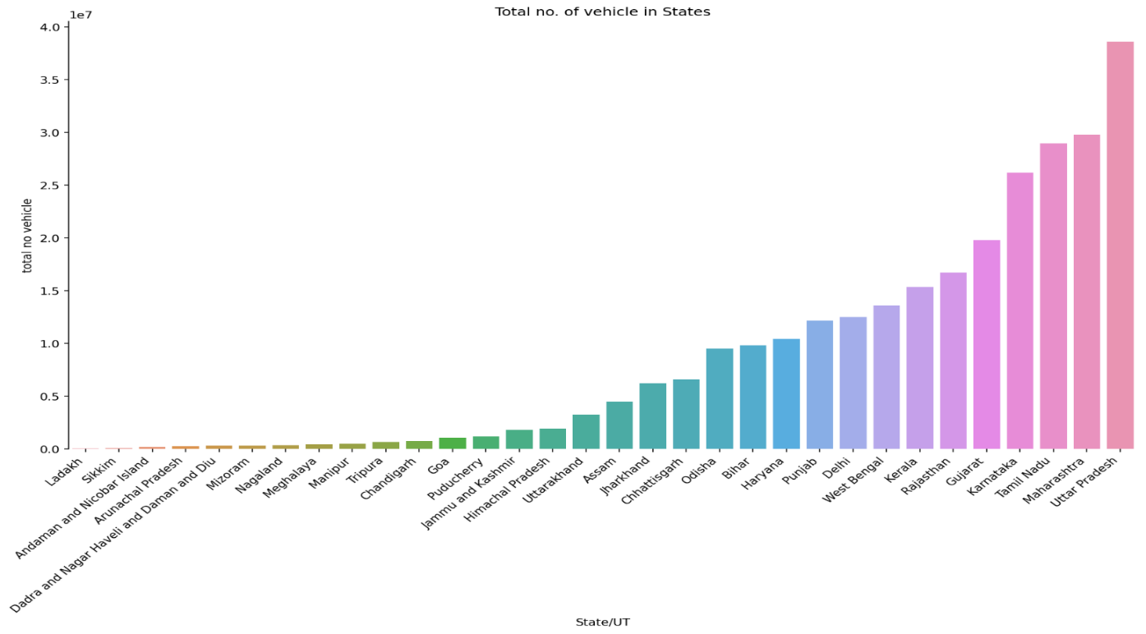

**Projection of electric vehicle in India**

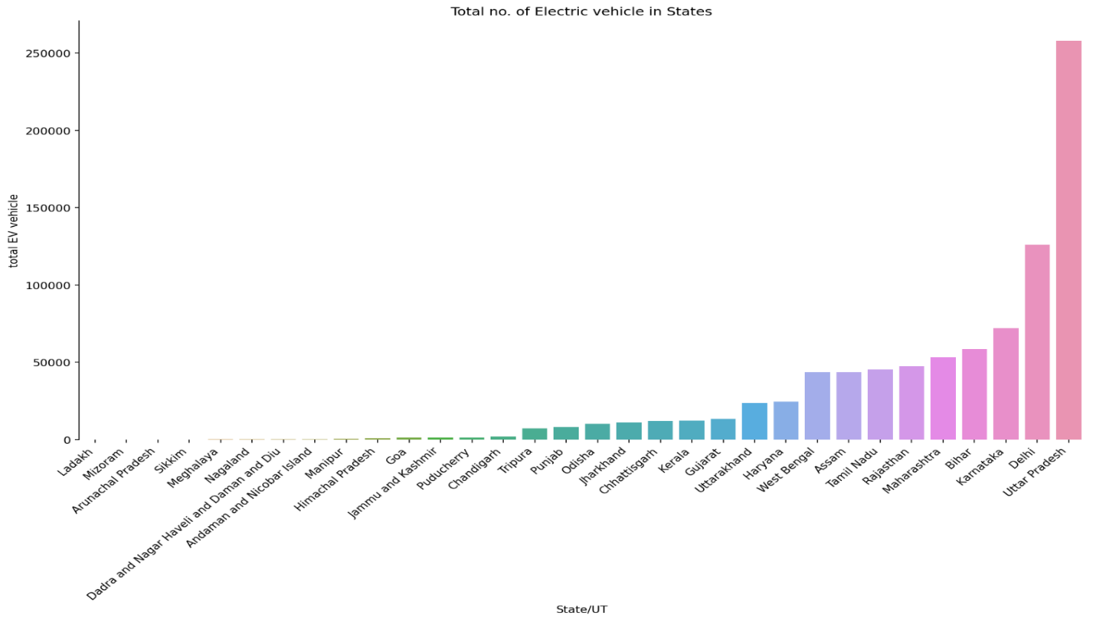States Uttar Pradesh, Delhi, Karnataka, Bihar and Maharashtra are having top numbers of electric population.

**Comparing the ratio of total vehicle with that** 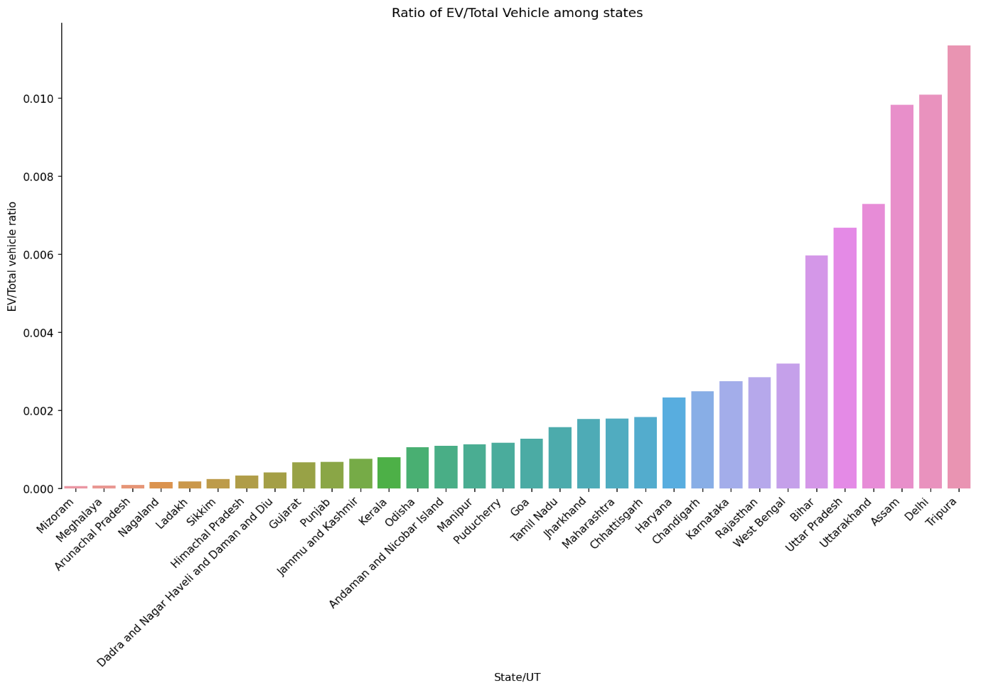

of EV’s in that state we can derive that people of Tripura, Delhi, Assam, Uttara Khand and Uttar Pradesh are having an edge in adopting Electric Vehicle as their choice. May be, it is the impact of literacy, awareness about pollution or the government schemes that leads to it. That’s rest to further insights.

**EV charging stations across States/UT**

EV charging station availability tells about ease of recharging electric vehicle and that can impact the consumers to adopt electric vehicles at pace.

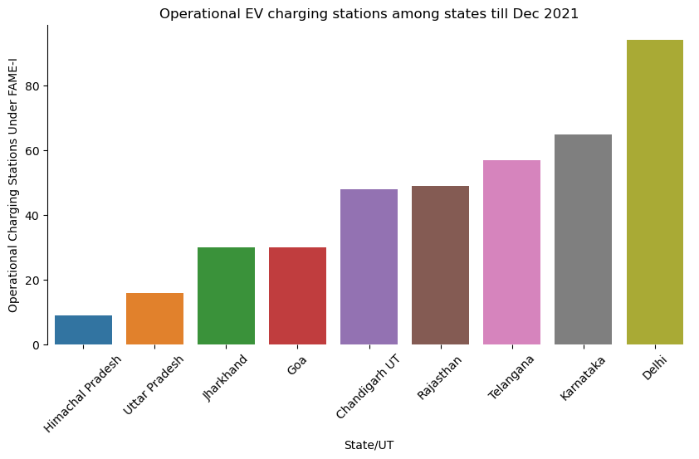

States like Delhi Karnataka Telangana Rajasthan and Chandigarh should be given more preference in policy decisions while roll out for EV’s.

**Projections of EV stations in cities**

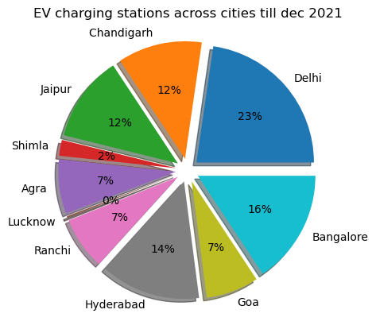

EV charging station are more in megacities so we should focus on megacities like Delhi, Bangalore, Hyderabad, and Chandigarh while deciding for policy related to EV cars.

**Sanctioned vs Deployed Charging stations**

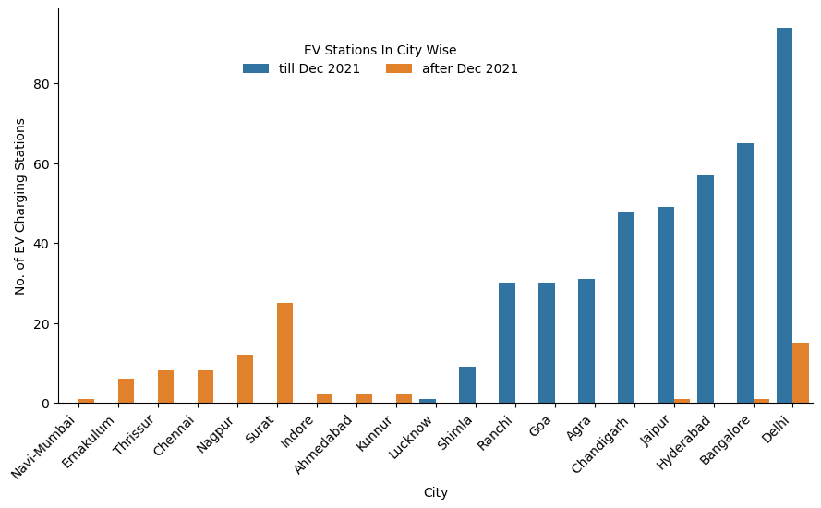

Blue bars show the EV stations deployed till Dec 2021 orange ones show the new deployed stations across new cities as well.

EV charging stations are deployed in new cities like Surat, Nagpur, Thrissur etc. as well new stations in previous cities but rate of deployment is low.

**New sanctioned stations at states**

The histogram below shows the number newly sanctioned EV charging stations across states like Maharashtra, Tamil Nadu, and Madhya Pradesh etc. have the largest number of deployed stations. These states have been lagging in EV charging stations but if the deployment happens then it would be invest in EV vehicles across these states.

But the matter of concern could be rate of deployment after being sanctioned as very few new stations have been deployed in states.

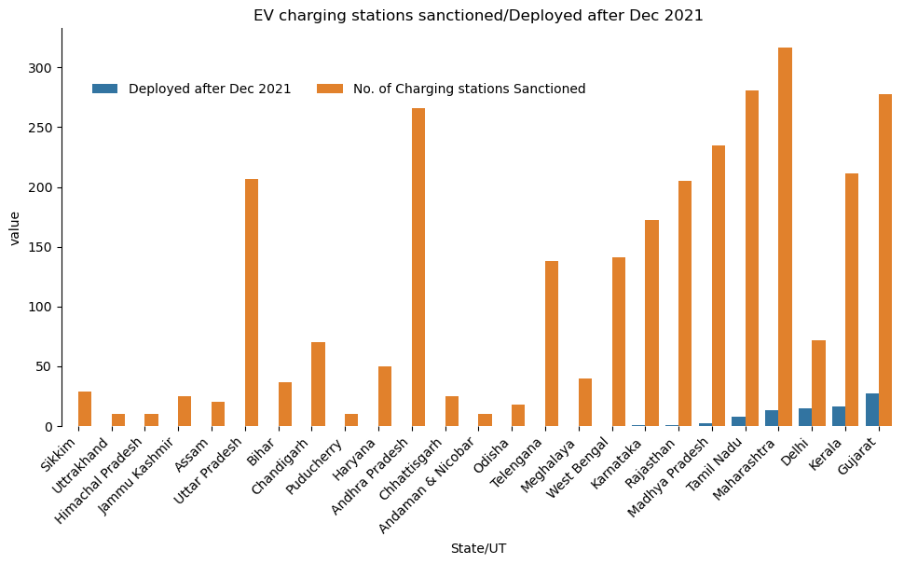

**EV charging station on highways and expressway**

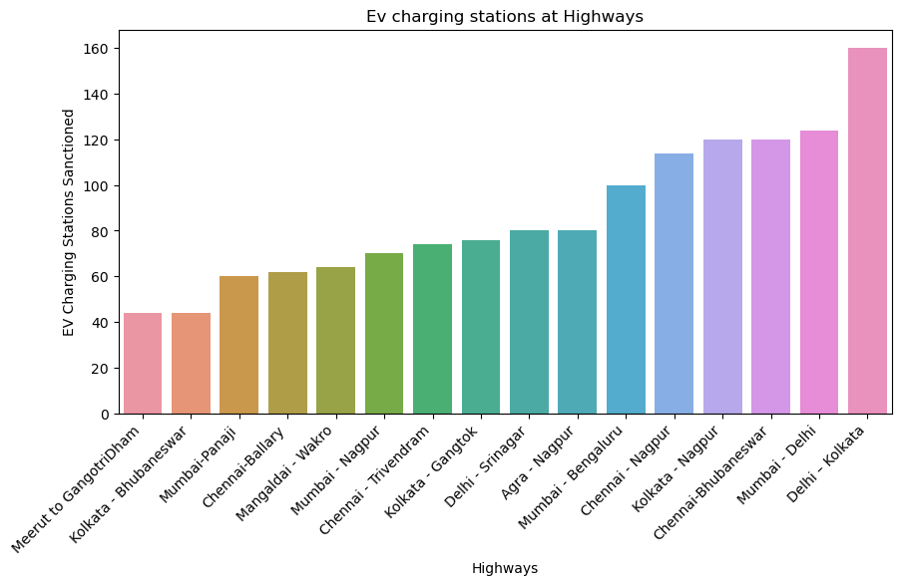Delhi-Kolkata, Mumbai-Delhi, Chennai-Bhubaneshwar highways are the leading in EV stations

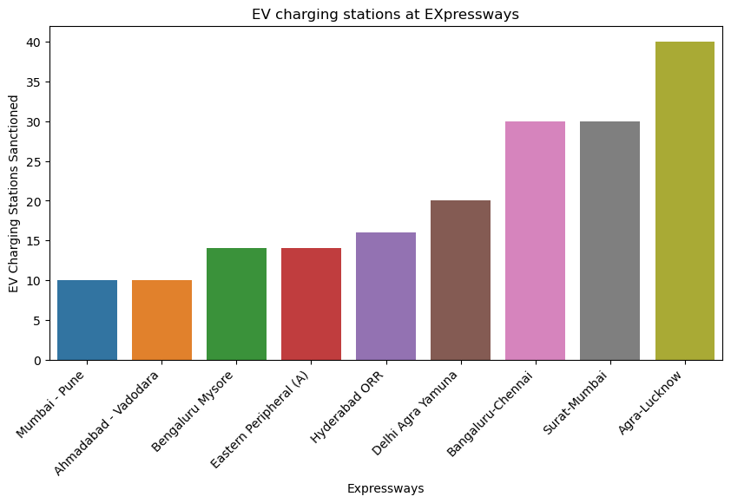

Agra-Lucknow, Surat-Mumbai, Bengaluru-Chennai are having high number of stations but the remaining expressways are also having average EV stations.

**K-means Clustering**

So to determine the regions having same characteristics are to be grouped based on states . to get a better insights into the regional variance the following variable have been taken into account

1. Total number of vehicles.
2. Charging station across states
3. Ratio of EV to the total vehicles

After doing the clustering to get optimal number of clusters plot of inertia vs cluster have been plotted to get elbow point.

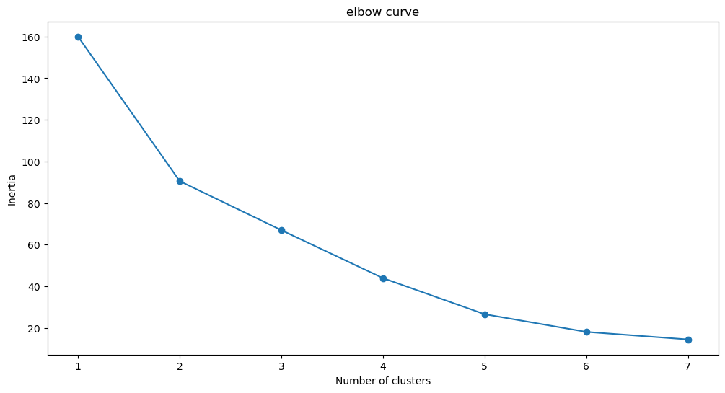

From the above curve optimal number of clusters can be selected as 5.

**Plot of clusters**

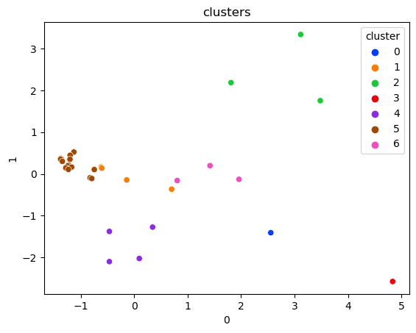

Here we can see clusters 5, cluster 4, cluster 2, cluster 6 are well separated when we take geographical segmentation as segmentation variable.

**Clusters of Regional Groups**

After clustering grouping based on regional variable have been shown

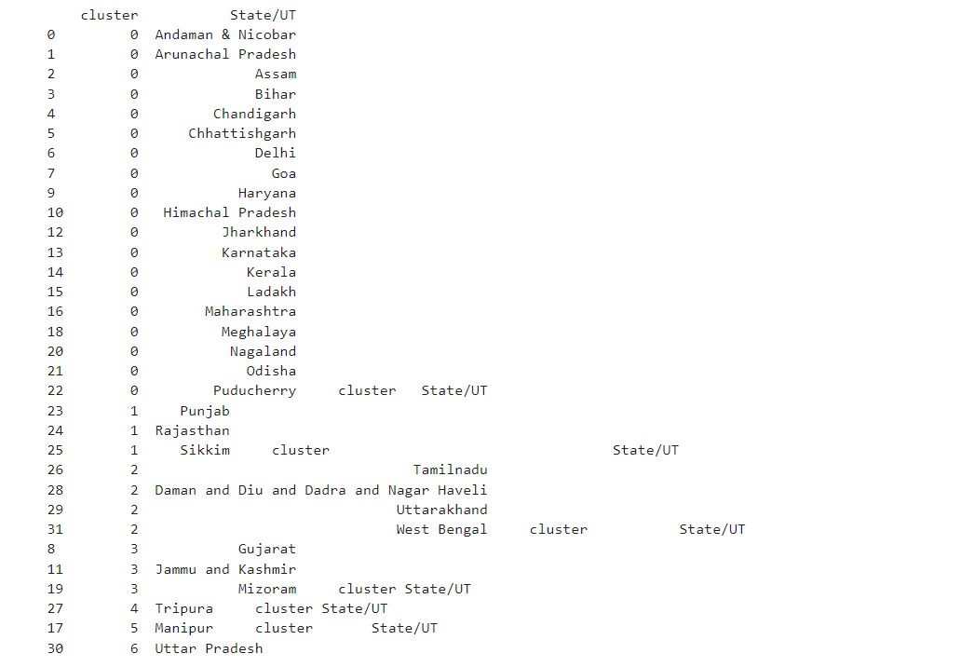

**Conclusion**

From this analysis we can easily conclude that based on Geographical segmentation variable we can divide whole states of India across 5 regions. Based on EDA we can select which group are beneficial as they tell us about regions with leading parameters such as no. of vehicles, no. charging stations, interest of energy sector companies etc.

**TASK 2 :**

**Psychographic Segmentation (based on preferred Electric Vehicle Type):**

**Problem Statement:**

When opening a new startup based on EV market, the analysis of the preferred types of vehicles by the end-users/ customers is of utmost importance. So, the problem statement that I am covering here is to analyze the psychographic segment of the data available. This will aid us in preparing new strategies to deploy in marketing and increasing revenue or sales

**Steps :**

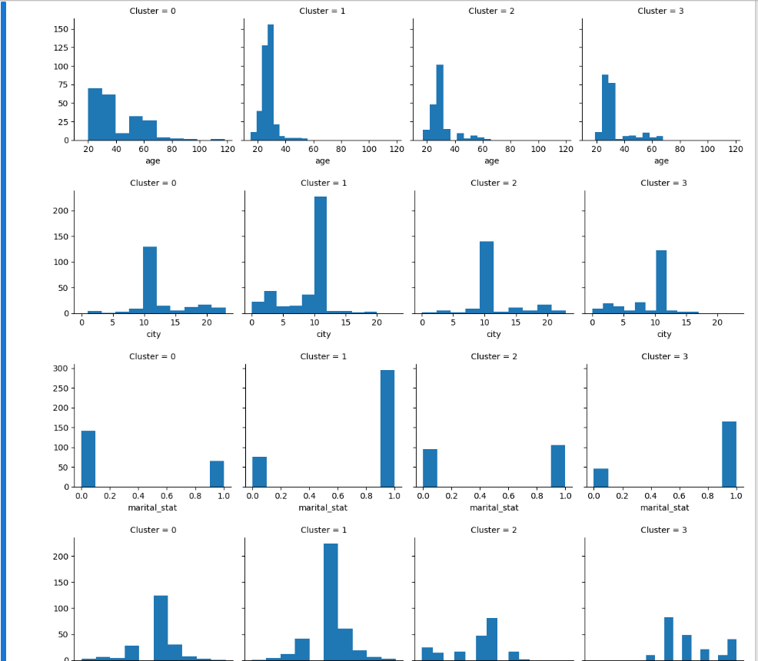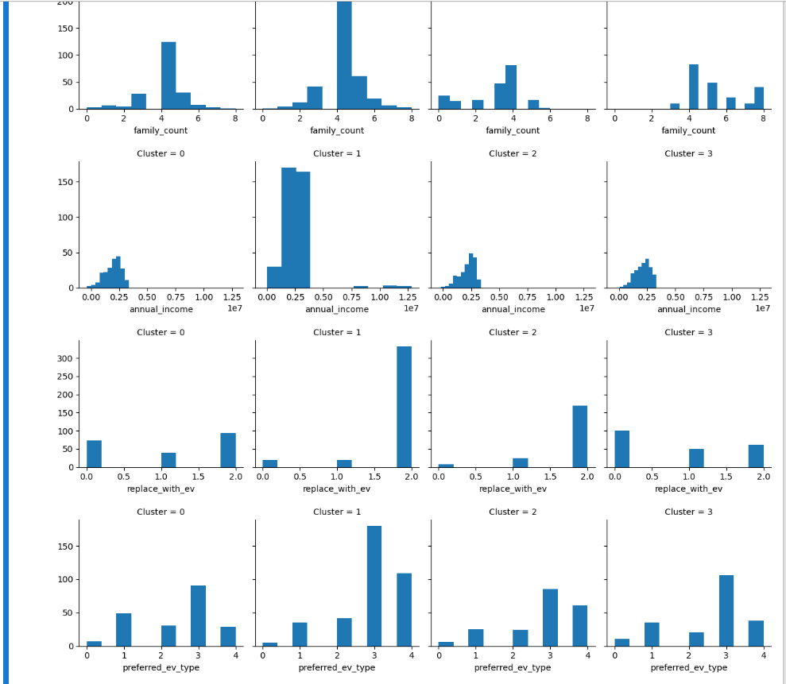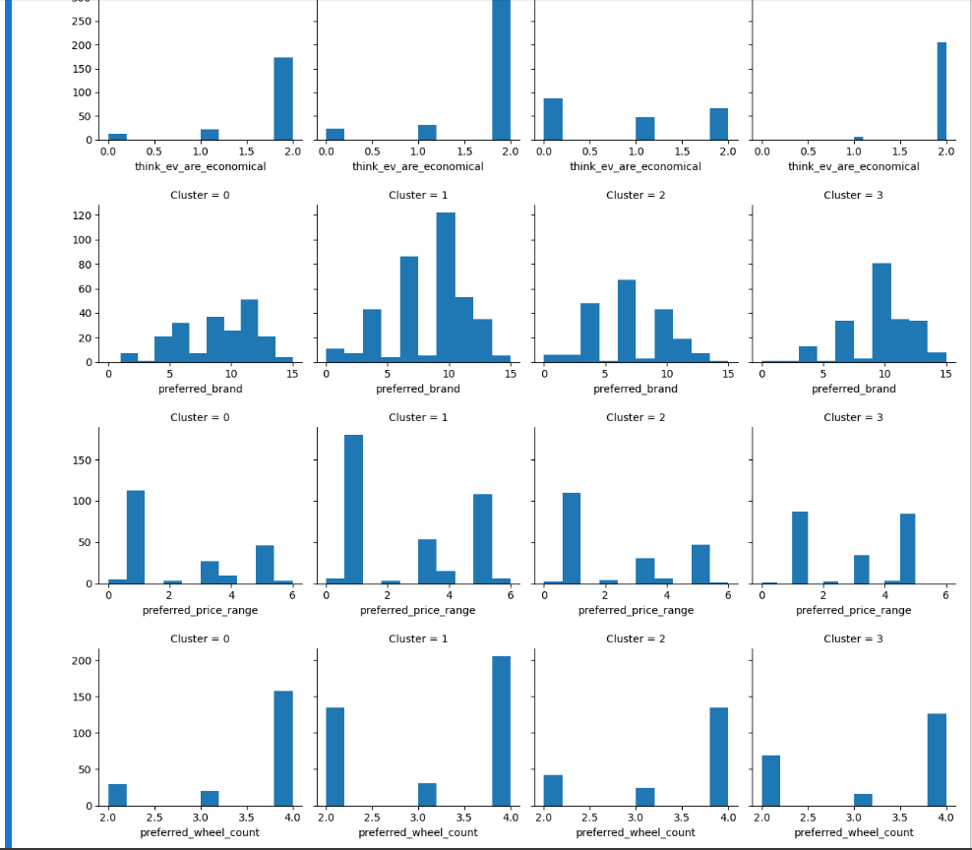

**Conclusions:**

o E4W (Electric 4 Wheeler) are the most popular with E3W (Electric 4 Wheeler) being the least popular in all the segments.

o Cars should be produced between marketing price of 5-15 lacs. o Tata, Hyundai and Kia are the most preferred brand among all the segments.

o SUV and Sedan are the most popular vehicle type found in all the clusters. So, these are to be manufactured in maximum numbers

**ANALYSING THE MARKET TRENDS**

There are several different variables by which segmentation is done:

**1. Geographic segmentation** :Geographic segmentation consists of creating different groups of customers based on geographic boundaries. The needs and interests of potential customers vary according to their geographic location, climate and region, and understanding this allows you to determine where to sell and advertise a brand, as well as where to expand a business.

● Charging station by State wise: State wise charging station will become a significant effect on consumer purchasing decisions. Those states with more charging stations may prefer to buy an EV and vice versa.

**2. Psychographic segmentation :** Psychographic segmentation consists of grouping the target audience based on their behavior, lifestyle, attitudes and interests. To understand the target audience, market research methods such as focus groups, surveys, interviews and case studies can be successful in compiling this type of conclusion.

● Lifestyle: A consumer whose profession is more time consuming than other average consumers , that consumer may select a vehicle who takes less time to charge a vehicle. This group of consumers only focus on the time required to charge an EV.

● Interests : Some consumers may have interest in particular manufacturing companies. Some consumers may like only vehicles made by the Tata company.

● Behaviour : Behaviour of consumers is the most important factor in the market segment. It shows what exactly consumers want from us?. Some consumers may want an EV who will cover far distance per a charging. Customizing the Market Mix The marketing mix refers to the set of actions, or tactics, that a company uses to promote its brand or product in the market. The 4Ps make up a typical marketing mix - Price, Product, Promotion and Place.

● Price: Refers to the value that is put for a product. It depends on costs of production, segment targeted, ability of the market to pay, supply - demand and a host of other direct and indirect factors. There can be several types of pricing strategies, each tied in with an overall business plan.

● Product: Refers to the item actually being sold. The product must deliver a minimum level of performance; otherwise even the best work on the other elements of the marketing mix won't do any good.

● Place: Refers to the point of sale. In every industry, catching the eye of the consumer and making it easy for her to buy it is the main aim of a good distribution or 'place' strategy. Retailers pay a premium for the right location. In fact, the mantra of a successful retail business is 'location, location, location’.

● Promotion: This refers to all the activities undertaken to make the product or service known to the user and trade. This can include advertising, word of mouth, press reports, incentives, commissions and awards to the trade. It can also include consumer schemes, direct marketing, contests and prizes. All the elements of the marketing mix influence each other. They make up the business plan for a company and handle it right, and can give it great success. The marketing mix needs a lot of understanding, market research and consultation with several people, from users to trade to manufacturing and several others.

**TARGET SEGMENTS**

Target marketing involves breaking a market into segments and then concentrating your marketing efforts on one or a few key segments consisting of the customers whose needs and desires most closely match your product or service offerings. It can be the key to attracting new business, increasing sales, and making your business a success. It can be concluded from above figures that Range, Top Speed, Full charging time, Income and Types of Vehicles can be the most important segment categories for consumer purchasing decisions. These are the key factors who make markets different and similar at the same time. This segments have formed with distinct features which may indicate that their preferences for EVs are motivated by different factors.

**Github:**

<https://github.com/Bhaskar55555/Market-Segmentation-analysis-of-Electric-Vehicle-1>